
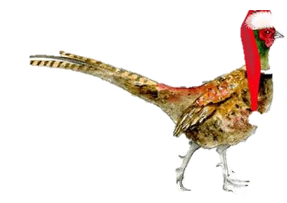
Christmas at The Pheasant Brill
To Start
Vegetable & Ham Hock Winter Broth
Vegetarian Winter Broth V VG DF
Chicken Liver & Truffle Parfait, Oxford sauce, Melba Toast GF
Smoked Salmon & Prawn Cocktail, Marie Rose Sauce, Home Baked Bread GF
Salad of Pan-Fried Mushrooms, Wild Garlic Pesto V VG GF DF
Macsweens Haggis Fritters, Malt Whisky Gravy

Main Event
Traditional Roast Turkey, Sage & Apricot Stuffing, Pigs in Blankets, Turkey Gravy DF GF
Roast Sirloin of Boarstall Beef, Yorkshire Pudding, Roast Gravy DF GF
Venison Wellington, Bourguignon Sauce, Pomme Puree
“Seafood Thermidor”
Scallops, Cod, Salmon, Prawns, Mussels, Baked in Mustard Sauce & Gruyere Cheese
Aubergine, Wild Rice & Spinach Roll Mops, Caponata, Festive Onion Rings V VG GF DF

Roast Potatoes & Festive Vegetables V VG DF

Dessert
Traditional Christmas Pudding with Brandy Sauce V VG
Festive Eton Mess, Seasonal Flavours & Fresh Fruits
Terry’s Chocolate Orange Cheesecake
Poached Fruits, Mulled Wine Sorbet V VG GF
Selection of Cheese
Freshly Ground Coffee, Tea & Mince Pies Included
£38 for 3 Courses / £30 for 2 Courses

All of our food is cooked fresh to order, we appreciate your patience during busy periods.
Key GF- Gluten Free DF - Dairy Free V – Vegetarian VG – Vegan
Any listed in red can be adapted to accommodate. Available from the 1st - 24th December. A non-refundable deposit of £10 per head will be required to secure your booking. We will contact you prior to your booking for your pre-order & dietary requirements. A discretionary 10% Service Charge will be added to all tables.
To Book email us at info@thepheasantbrill.co.uk Or Call 01844 239370

